Figures
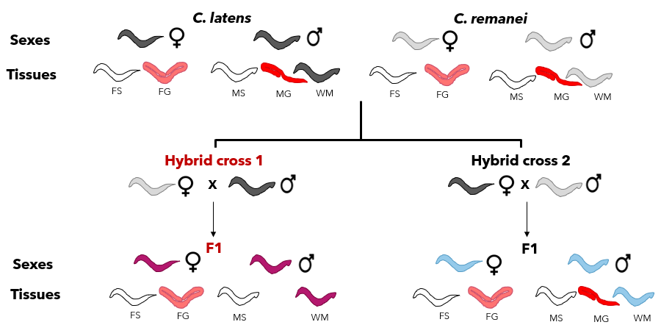
Figure 1:Schematic representation of sample construction. The RNASeq dataset consists of three replicates for each of 19 treatments, comprised of two sexes (females (F) and males (M)) and two tissues per sex (gonad (G) and somatic tissue (S)) derived from each of two wildtype species (C. latens (black) and C. remanei (grey)), as well as the two reciprocal hybrid classes (H1 cross (pink) and H2 cross (blue)). The exception to this factorial sampling is exclusion of male gonad samples from hybrid cross 1 (H1), due to inability to isolate them reliably. Whole male samples (WM) were also collected for each of the species and hybrid combinations.
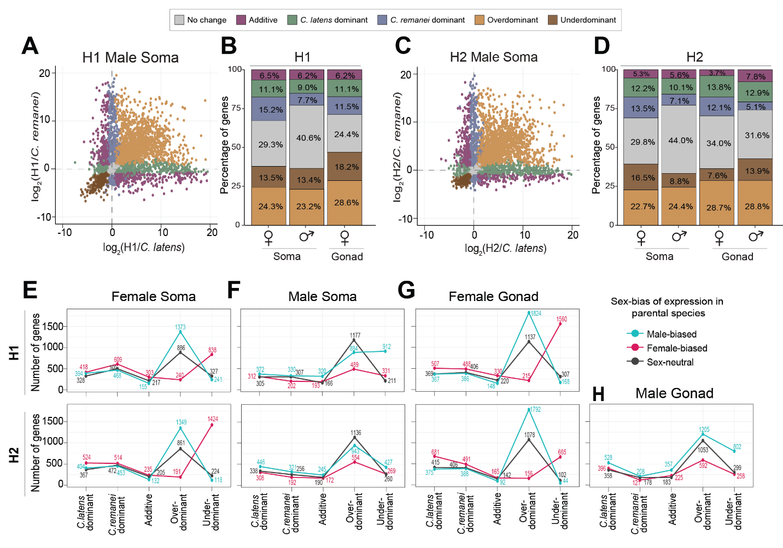
Figure 2: Hybrids reveal extensive transgressive overdominant and underdominant expression in both sexes and for both soma and gonad tissue types. (A, C) Scatterplots visualizing different gene expression inheritance categories based on log fold change in soma sample expression for hybrid males relative to each parental species C. remanei and C. latens. Plots for male gonad expression as well as female gonad and soma expression are shown in Supplementary Figure S4. (B, D) Barplots depicting the percentage of genes showing different expression inheritance profiles from each hybrid cross direction for each sex and tissue type. (E-H) Transgressive expression in hybrids (overdominant and underdominant) consist mostly of genes with sex-biased expression in the parental species. Plots on the top row correspond to H1 hybrids (C. remanei maternal parent) and bottom row corresponds to H2 hybrids (C. latens maternal parent). The three lines depict the number of male-biased genes (blue), female-biased genes (pink) and sex-neutral genes (black) observed across inheritance profiles for each sex, tissue type and reciprocal cross. Hybrid females tend to have upregulation of male-biased genes and downregulation of female-biased genes (E, G). Hybrid males show misexpression primarily due to sex-neutral and male-biased genes (F, H). Genes with the ambiguous expression inheritance category are not shown for clarity.
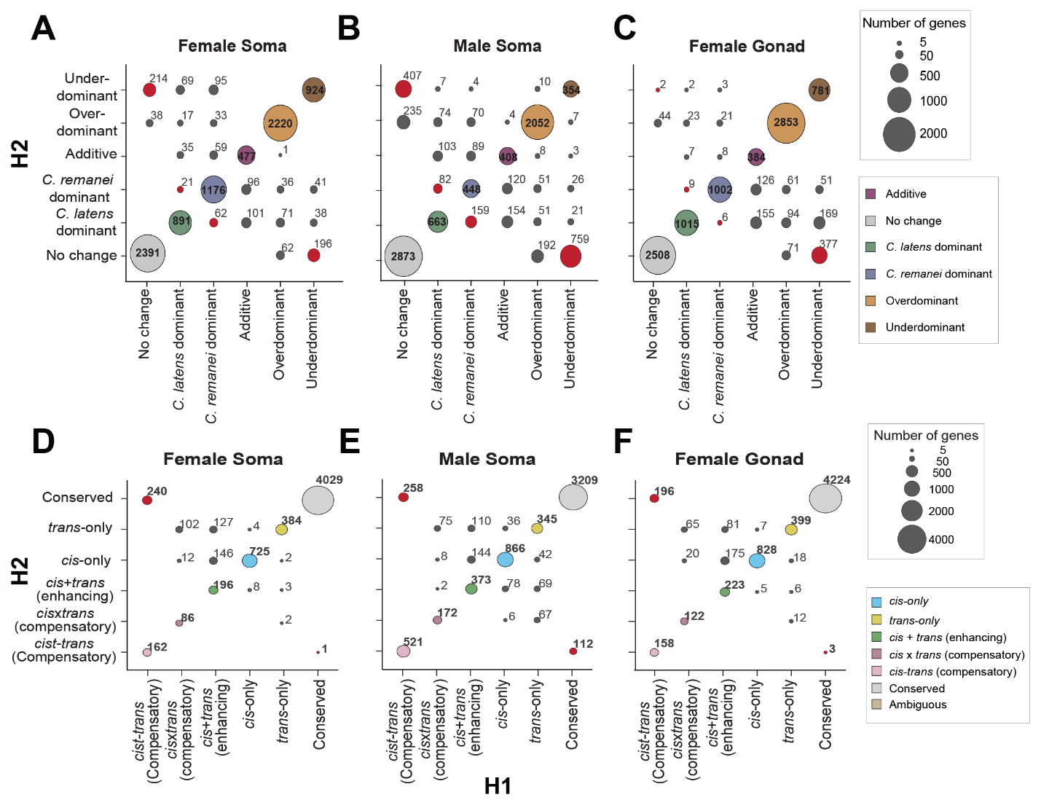
Figure 3: Despite higher overlap in genes across reciprocal crosses, H1 and H2 display distinct patterns for expression inheritance and regulatory divergence. (A, B, C) Bubble plots contrasting the genes in each expression inheritance category across reciprocal crosses with area of the bubble proportional to the number of genes. The bubbles on the diagonal represent the number of genes overlapping between H1 (x-axis) and H2 (y-axis) and red bubbles highlight the number of genes showing underdominant expression exclusively in one hybrid cross. Females show a higher level of overlap in genes than males across reciprocal crosses (A, C, bubbles on the diagonal). Males have higher number of underdominant genes unique to each hybrid cross (B, red bubbles). (D, E, F) Bubble plots contrasting the genes and their regulatory divergence in H1 (x-axis) and H2 (y-axis). The bubbles on the diagonals represent the number of genes overlapping between H1 (x-axis) and H2 (y-axis) and red bubbles highlight the number of genes showing cis-trans compensatory divergence exclusively in one hybrid cross. More than 50% of genes showing cis-trans compensatory regulation in H1 females were conserved in H2 females. Only autosomal genes are represented for clarity as the X-linked genes were classified with a slightly different criteria due to their hemizygous nature in males (see methods; Supplementary Figure S2). Both autosomal and X-linked genes display similar patterns for male soma, however, in case of X-linked genes in female soma and gonad, no deviation is observed from the diagonal indicating hybrid-cross specific misregulation predominantly of autosomal genes in females (Supplementary figure S11).
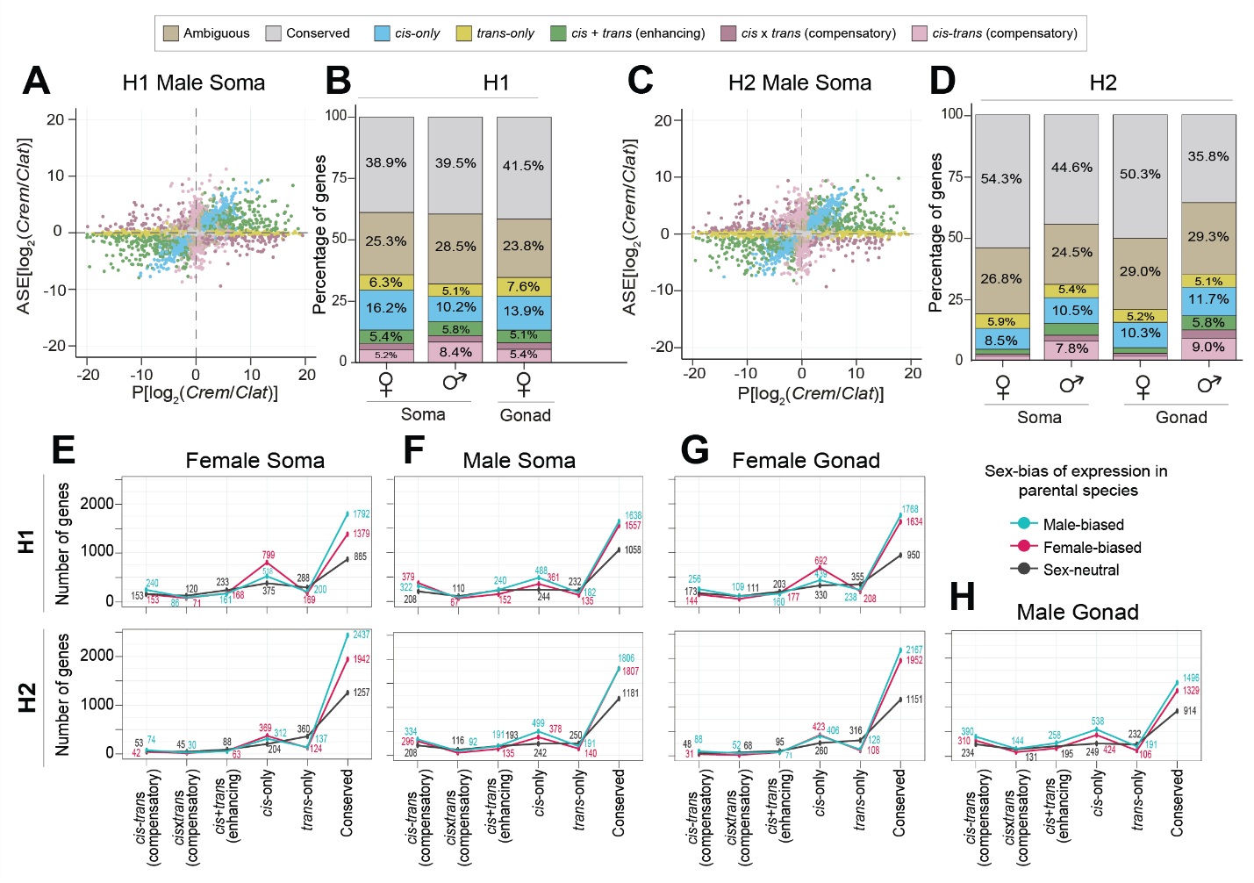
Figure 4: Gene misregulation differs between sexes and reciprocal hybrid crosses. (A, C) Classification of regulatory divergence using allele specific expression analysis. Gene expression between the species C. remanei (Crem) and C. latens (Clat) (x-axis) is compared to the expression difference between alleles within the hybrids (y-axis). Genes with conserved regulation across species are depicted in grey. Such genes show no expression difference between species as well as no difference between alleles within hybrids and fall on the origin (0,0). Scatterplots depicting regulatory divergence for genes expressed in male gonad, female soma and gonad are depicted in Supplementary Figure S7. (B, D) Barplots depicting the percentage of genes showing different regulatory divergence categories detected in each reciprocal cross H1 (maternal C. remanei hybrids) (B) and H2 (maternal C. latens hybrids) (D) for autosomal genes. More than ~38% of total genes in all samples displayed allele-specific expression profiles consistent with regulatory conservation. H2 males displayed an overall higher number of genes showing regulatory divergence (predominantly cis-only and cis-trans compensatory divergence) than females (n_{MS} = 3341; n_{FS} = 1979; n_{MG} = 3655; n_{FG} = 2184). This pattern also broadly holds true for X-linked genes (Supplementary Figure S8). (E-H) Sex-biased genes display conserved regulation or cis-only regulatory divergence. cis-only divergence disproportionately influences female-biased genes in hybrid females (E, G) and male-biased genes in hybrid males (F, H). In contrast, trans-only divergence tends to affect sex-neutral genes in both sexes. Genes with ambiguous expression categorization not shown for clarity. Plots on the top row correspond to H1 hybrids (C. remanei maternal parent) and bottom row corresponds to H2 hybrids (C. latens maternal parent). While this line plot represents autosomal genes, it is important to note that cis-trans compensatory divergence also plays a role in the misexpression of sex-biased genes, particularly in males with respect to X-linked genes (Supplementary Figure S9).
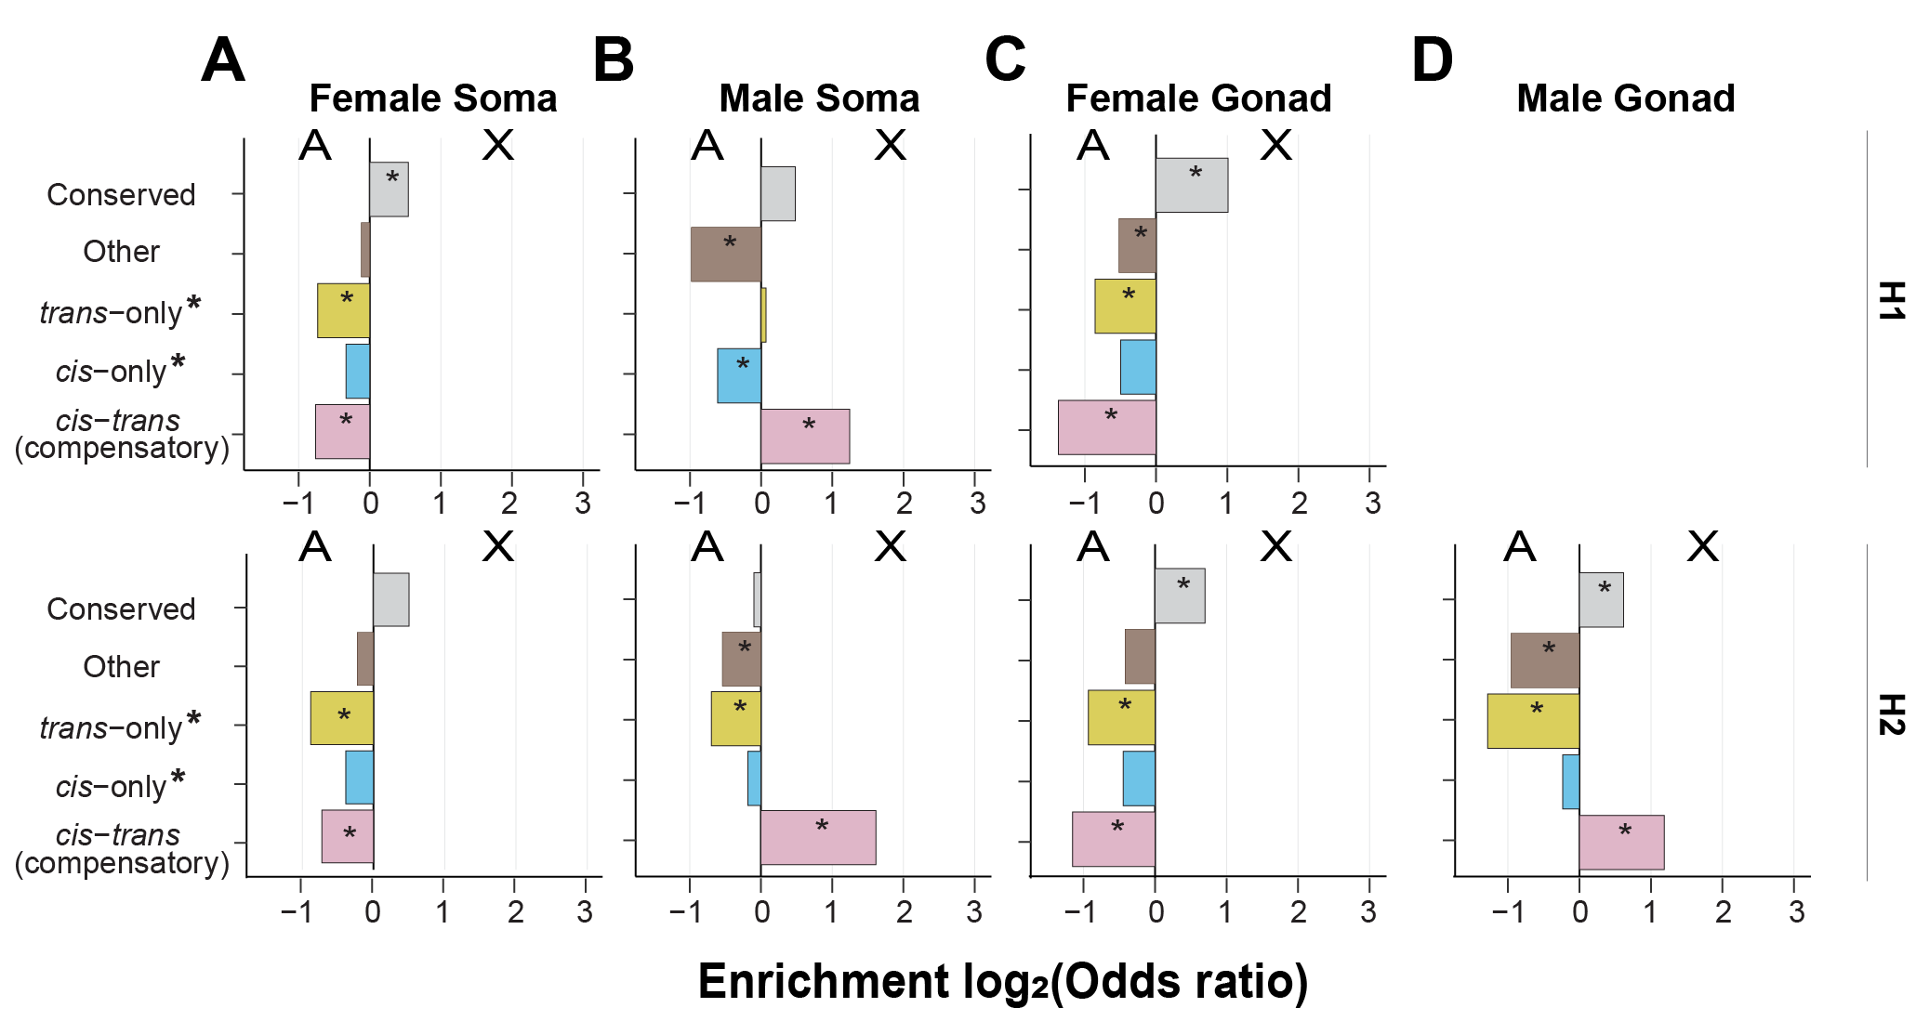
Figure 5: cis-trans compensatory changes are enriched on the male X-chromosome. Enrichment of genes linked to autosomes versus X-chromosomes for different categories of regulatory divergence inferred from soma (A, B) and gonad (C, D) tissue types of females (A, C) and males (B, D) for H1 hybrids (top row, maternal C. remanei hybrids) and H2 hybrids (bottom row, maternal C. latens hybrids). H1 hybrids have C. remanei maternal parents; H2 hybrids have C. latens maternal parents. Positive values of the log₂(odds ratio) denote enrichment for the X-chromosome and negative values indicate enrichment for autosomes. The X-chromosome of males exhibited an enrichment of genes displaying cis-trans compensatory regulatory divergence, whereas such genes were underrepresented on the X-chromosomes of females. Regulatory categories defined according to the restricted criteria used for X-chromosomes in males (Supplementary Figure S2).
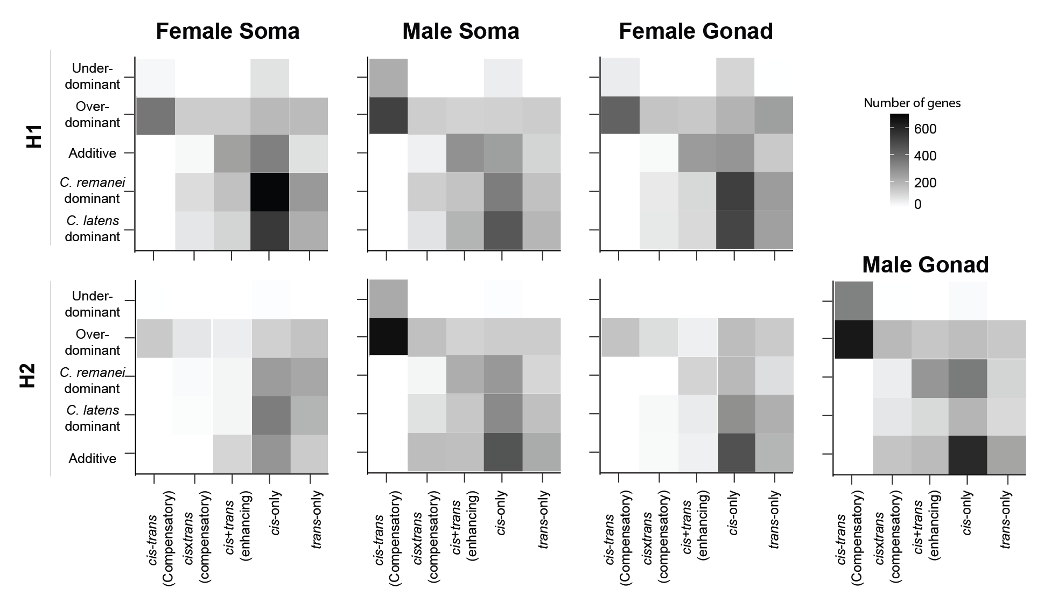
Figure 6: cis- and trans- changes underlie higher proportion of transgressive genes in both sexes. Heatmap with number of genes in different regulatory divergence categories for each expression inheritance profile to identify gene regulatory divergence underlying transgressive expression in autosomes. Males and females show different gene regulatory divergence underlying gene misexpression with higher contributions of cis-trans compensatory divergence to transgressive expression in males. The regulatory divergence for X-linked genes in males was inferred in a different way (see methods) due to the hemizygous nature of the X-chromosome in males (Supplementary Figure S2) but display similar pattern as autosomes and are depicted in Supplementary Figure S12. The top row shows results from H1 hybrids (C. remanei mother) and bottom row shows results from H2 hybrids (C. latens mother).

